**Aftermarket Vincent Tank Review of Vintage Bike USA Tank (VBU)**

*DRAFT* January 8th, 2022

By Mark Scott

**Packaging**

Item arrived well packaged with multiple layers of bubble wrap and a styrofoam base and top. Externally, the box looked a bit battered but internally there was no visible damage to the tank. There was a smell of fresh paint. All surfaces appeared properly coated.

**Test bike**: 1948 Vincent Rapide ‘B’. Parts in Photos Referenced as ‘**Stock**’: Caveat: I have no proof that the tank on my bike is an original. My bike is non matching so there is a significant chance that my tanks did not originally come fitted to my UFM. However, it fits well.

**Preliminary Alignment and Fit Review**

1. Front tank tabs appear parallel and properly aligned. With mounting bolts securing front tabs, the rear tab lines up properly with the mounting holes as shown below:

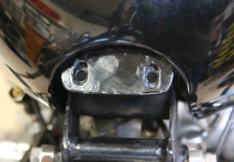

1. Front **VBU** tabs are just under 5mm wider that the **Stock. Stock** fits tightly on the mount

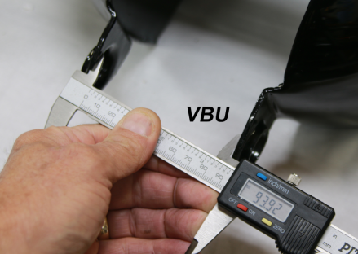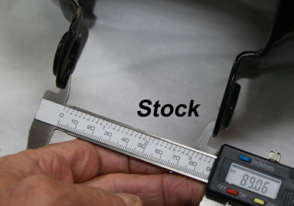

Resulting in the gap shown below, with gromets installed. **Stock** has an interference fit with gromets installed.

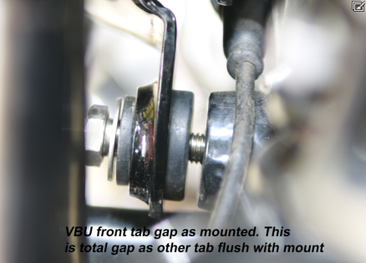

1. Front tab hole diameter in **VBU** is approximately 2mm bigger than Stock, resulting in loose fitting gromets. The left **VBU** tab diameter was slightly smaller than the right.

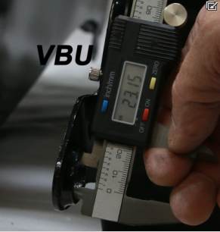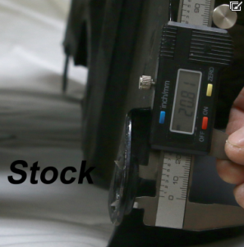

1. **VBU** rear tab is higher than Stock in its lowest mounting position as the lower cross brace tab fouls the Upper Frame Member (UFM) to cylinder head mounting bolt. (The **stock** tank sits flush in the mounting rubbers, without fouling UFM bolt). Note in the photo below that the cross brace support tube fits under the UFM with the mounting bolt through the cross support tab holes on either side of the tank. The position shown below is about the highest (as well as the lowest) possible mounting position of the rear of the tank, in order to fit the cross brace, and not fowl the UFM bolt.

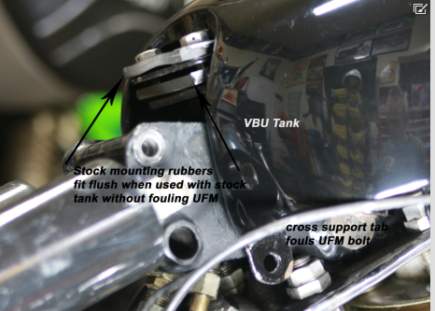

1. In the position of the rear of the tank as shown in #4 above, the oil tank neck does not center in the tank.

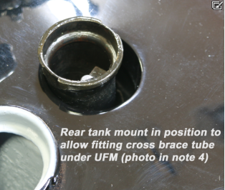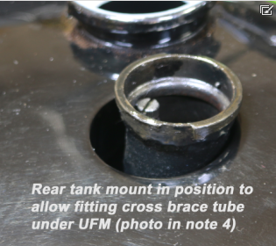

1. The rear of the tank can be lifted to adjust the fit of the oil filler neck in the tank hole, while pivoting on the front mounting tabs. The photos below show the height of the current rear tab that is needed to center the oil fill in the tank hole. Note that the rear cross brace tab holes now line up into the UFM, making the cross brace non-mountable

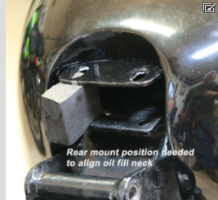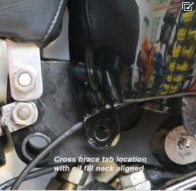

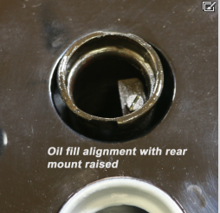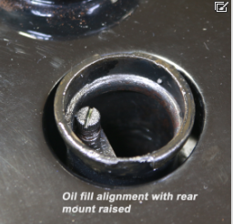

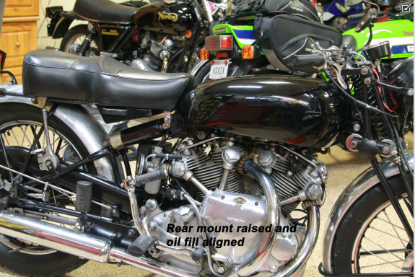

1. The oil fill neck was better centered in the hole with rubber shims, with the tank supported on the UFM with a rubber spacer to check alignment of the front and rear mounts while the neck was better centered in the hole. The rear mount was in the low position, where the cross brace could be mounted. This resulted in the following:

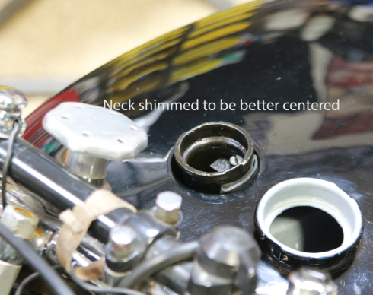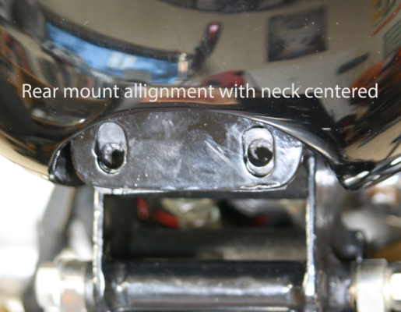

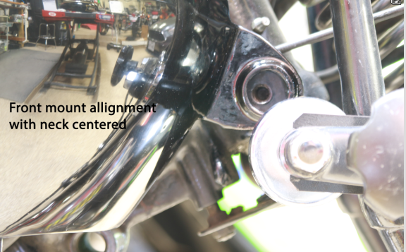

**Conclusion**

Appendix

**Link to photos:** [**https://www.tank-test.austinvintagewheels.com/**](https://www.tank-test.austinvintagewheels.com/)

**Order information**

The tank was ordered on December 10th 2021, shipped on December 28th and delivered on December 31st. At the shipping date, the expected delivery date was January 18th 2022.

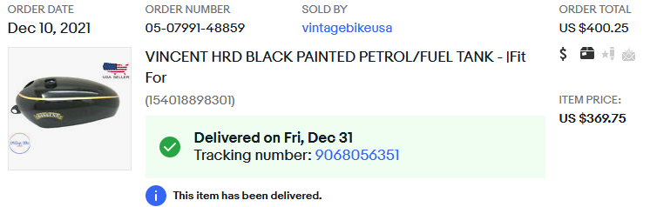

**Description by Seller**

**We are a California, USA based company and all the items in our eBay store are manufactured in India.**

**Here are the benefits in doing business with a USA based company:**

* **Highest standards of quality control on all items**
* **Excellent customer support based out of California, USA**
* **Guaranteed delivery, quality and fit for all our items**
* **Easy returns with items to be shipped to our return address in California**
* **Faster delivery times with some items shipped directly from our manufacturing unit in India**

**Unlike our competitors we deal in TOP QUALITY ITEMS and use high grade steel sheets, welding, paint and triple plate chrome. Our prices reflect the workmanship and quality of our products!**

**ABOUT US**

Vintage Bike USA is a leading automobile parts service provider located in California, USA. When it comes to keeping an eye on the Pulse of Vintage Bikes spare parts, no one does it better than the Vintage Bike USA!

We are one of the top manufacturers & suppliers of classic and vintage bike spare parts. We have our own manufacturing unit in India, where we use top quality material which meets the highest industry standards to prepare various vintage spare parts like - Petrol tanks, Mudguards, Oil tanks and all spare parts of Vintage & Classic Bikes.

**PAYMENTS**

We accept payments through all major payment systems, including the following: PayPal, Apple Pay, Visa, Master Card, American Express and Discover.

**SHIPMENT**

Handling time is usually 15-20 business days. We use economy shipping which may take 5 to 10 business days to reach the consignee after the dispatch of the item. Please indicate your full door address. Shipment cannot be delivered to a P.O. Box address.

Goods are professionally packed to prevent damages during transit.

WE WILL GIVE YOU A DISCOUNT ON POSTAGE IF YOU BUY MULTIPLE ITEMS FROM OUR EBAY SHOP.

**Do mention your confirmed shipping address and current contact number while placing the order to avoid shipment delays owing to insufficient information.**

Returns are acceptable within 14 days of item received and the return shipping will be borne by the buyer.

**DISCLAIMER**

Raw Items purchased from our store: Please note that if Raw / unfinished item is bought from our store, then it could have some surface rust on it (inside & outside). We use steel sheets to manufacture the items and it is the natural property of steel to catch rust. We do apply primer temporary coat on many of our raw items, but rust could be still visible, which cannot be construed as an issue with the item. This can be easily fixed at the time of paint / chrome at your end and won’t require any additional process or cost anything more. We will not entertain any issue in this regard, which please note.

Painted items purchased from our store: Please note that although, we give ample time to our painted items to dry-up, but there is a chance that there could be some packing marks seen on the item received. The marks are on top of the lacquer (automotive standard lacquer), which is protecting the paint underneath. This could be easily removed by applying any good quality rubbing polish (3M) with the help of a soft cloth and you will see the marks vanishing right in front of your eyes. We also apply sealer inside of the tank, but we encourage our customers to apply their inside lining to give extra protection. Any rust seen inside is already covered with transparent lining applied by us. Another inside lining by the customer at their end will give enhanced protection. We will not entertain any issue with regard to the packing marks or inside surface rust, which please note.

The items are a reproduction of the original models. Please refer to the model description and compatibility with your vehicle before buying/ bidding for early models.

Since items are handmade & most items are made to order, therefore, no two items can be identical and there can be little variation in the same. Also, the color of the item received may vary a little from the color in the picture.

It is requested from our customers to NOT to ACCEPT packages in damaged or wet condition from the courier and put a remark for the same in writing with them. We cannot assume any responsibility for accepting packages in the above condition.

By purchasing any item sold here, the buyer accepts that he/she is in compliance with local laws and regulations regarding the purchase, ownership, and use of the item. The buyer agrees to indemnify and hold harmless our eBay store, company or its licensors for all claims resulting directly or indirectly from the purchase, ownership, use or misuse of the item in violation of applicable Federal, State, and Local laws or regulations. You must be 18 or older to purchase.

Any/all trademarks mentioned on the eBay store and eBay listings are for descriptive purposes only and are the property of their respective owners.

**IMPORTANT NOTICE TO INTERNATIONAL BUYERS**

To avoid any subsequent misunderstandings, please note that importing goods from another country can mean that your national Customs authorities may charge you Customs Duty and/or other additional related taxes (for example, a Value Added Tax or a Purchase Tax). YOU, as the importer, are responsible for paying any such taxes. We have no control over what taxes you may be charged by your own national tax authorities. We are not responsible for compensating you for payment of any such taxes. If you do not know how much (if any) import tax you might have to pay, please check with your local tax authorities BEFORE entering into a contract to purchase.

If your goods are retained or confiscated by your own national customs authorities for any reason, it is your responsibility alone to negotiate with them the terms on which such goods might be released to you.

If your goods are undeliverable for any reason and are returned to us, we reserve the right to reclaim from you any associated costs which may be charged back to us.

On any customs forms, we declare the full purchase price as the value of the goods.

By purchasing any item sold here, the buyer accepts that he/she is in compliance with local laws and regulations regarding the purchase, ownership, and use of the item. The buyer agrees to indemnify and hold harmless our eBay store, company or its licensors for all claims resulting directly or indirectly from the purchase, ownership, use or misuse of the item in violation of applicable Federal, State, and Local laws or regulations. You must be 18 or older to purchase.

We are not authorized agents for any two wheeler manufacturers. Any/all trademarks mentioned on your eBay store and eBay listings are for descriptive purposes only and are the property of their respective owners.

**FEEDBACK**

Our business works on your trust on us. We rely heavily on your feedback and do request you to kindly leave your positive feedback to help us do even better.

In a rare occasion, if you are not satisfied with our product / service, then we request you to kindly write to us to solve the issue amicably. We will make our best efforts to address your complaints/grievances.

Please add us to your favorites / follow our ID for regular updates on our products. We are constantly adding more parts for vintage, classic motorcycles and more...

***Thank You,***

***Vintage Bike USA***